Introduction: there are 2 kinds of credit memos
- Credit memos regarding quantity and price
- Credit memos regarding only price ➔ named subsequent credits in SAP

- Credit memos
Select option 2 in MIRO
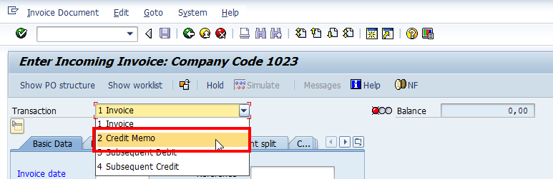

SAP will propose by default the invoiced amount because it is the maximum amount that it is possible to post
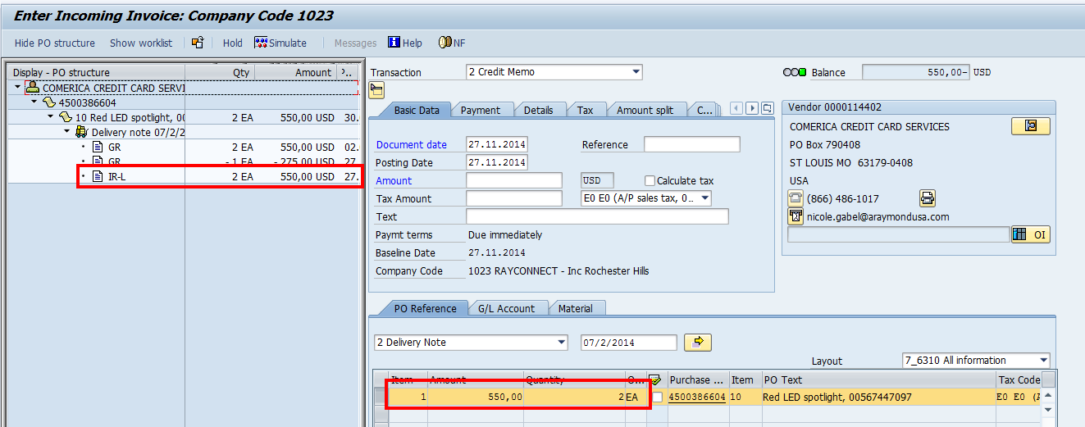

Adjust the quantity and price and click on Save
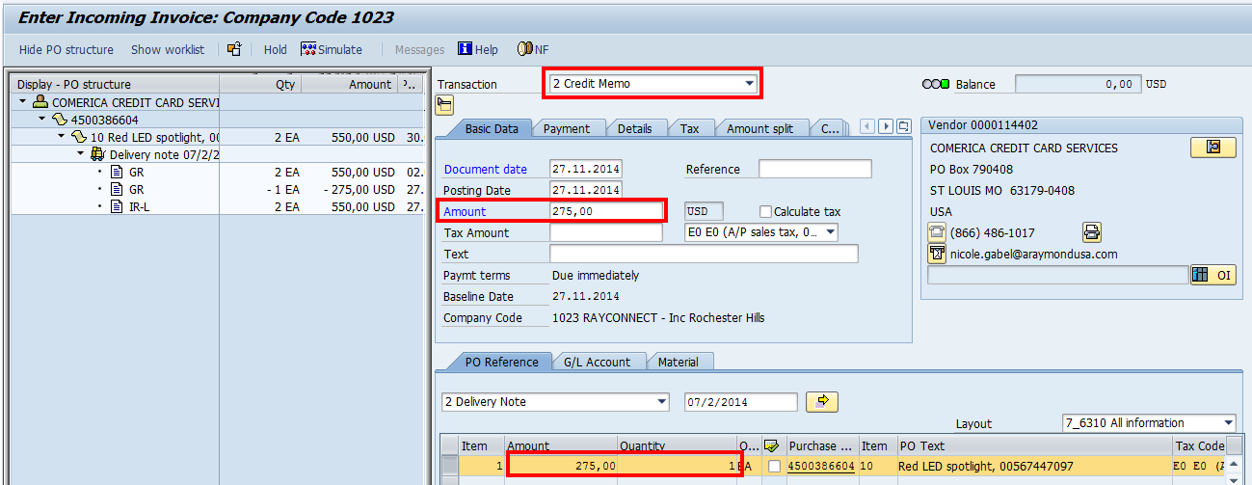

Accounting scheme will be as below
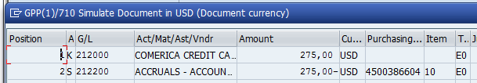

- Subsequent Credits

Select option 4 in MIRO:
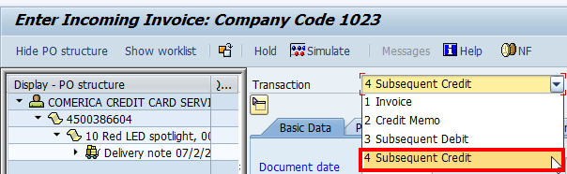

SAP will propose by default the invoiced quantity because this credit memo will apply the price decrease on the basis of invoiced quantities

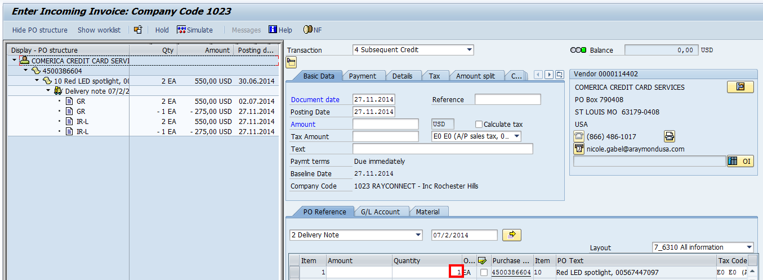

Adjust the quantity and price and click on Save
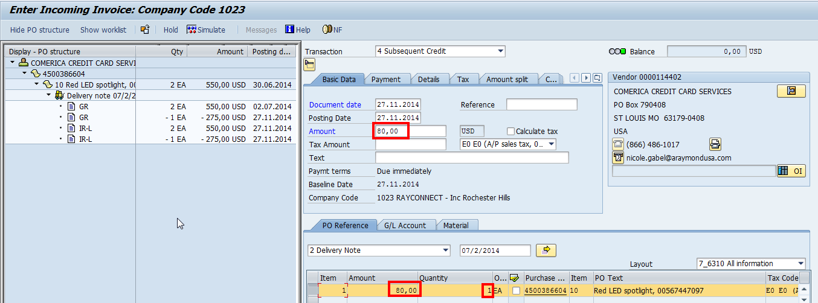

Accounting scheme will be as below
